Spring Pairs

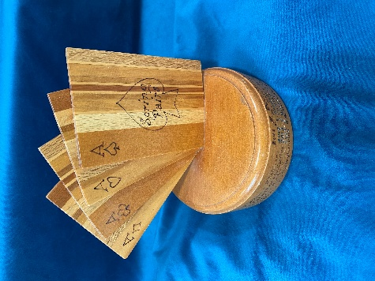

2025 John Patterson Maurice Carter
2024 Ross Gully Chris Marshall
2023 Faye Daken Joyce Allen
2022 Reg Nichol Barbara Fechney
2021 Jenniger Cunningham Lesley Pincombe
2020 Jim Blewitt Marty Gimpl
2019 Faye Daken Reg Nichol
2018 Judith Marshall Marty Gimpl
2017 Jennifer Cunningham Barbara Fechney
2016 E Roggeveen R Nichol
2015 G Black L Callaghan
2014 J Blewitt R Nichol
2013 J Cunningham K Harrop
2012 L Gledhill M McMurdo
2011 J Cunningham K Harrop
2010 J Allen L Callaghan
2009 G Low R Nichol
2008 L Callaghan W Gabities
2007 J Allen J Wilson

