President’s Pairs & Secretary’s Pairs
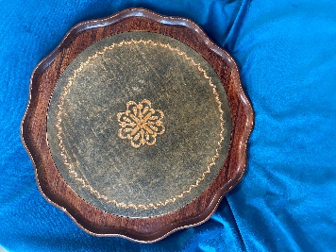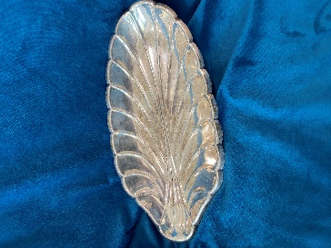

2025 Chris Marshall Maurice Carter 2025 Heather Rocco Ginno Rocco
2024 Maurice Carter Chris Marshall 2024 Margaret Marshall Ginny Warren
2023 Maurice Carter Barbara Fechney 2023 Neil Burrell Christine Holdaway
2022 Maurice Carter Barbara Fechney 2022 Reg Nichol Jennifer Cunningham
2021 Don Ellery Hand van Berlo 2021 Joyce Allen Adrienne Healey
2020 J Cunningham Reg Nichol 2020 Sally Lange Cec Warren
2019 J Cunningham Reg Nichol 2019 Judith Marshall Marty Gimpl
2018 Chris Marshall Maurice Carter 2018 Reg Nichol Jennifer Cunningham
2017 J Cunningham R Nichol 2017 Margaret Marshall Lynn Callaghan
2016 J Cunningham R Nichol 2016 Adrianne Healey Marty Gimpl
2015 J Cunningham R Nichol 2015 Chris Marshall Margaret Marshall
2014 B Fechney M Carter 2014 Chris Marshall Margaret Marshall
2013 C Marshall M Marshall 2013 Chris Marshall Margaret Marshall
2012 B Fechney M Carter 2012 Joyce Allen Greta Black
2011 B Fechney M Carter
2010 J Cunningham A Fletcher
2009 E Adams L Callaghan
2008 B Fechney M Carter
2007 B Fechney M Carter
2006 B Fechney M Carter
2005 J Gabara R Nichol
2004 D Crawford A O'Callaghan
2003 G Black J Allen
2002 F Daken C South
2001 F Daken C South
2000 E Adams L Callaghan
1999 F Daken C South
1998 F Daken C South
1997 F Daken C South
1996 T Bainbridge T Bourne
1995 M McMurdo T Bourne
1994 F Buck A O'Callaghan
1993 J Flavell A O'Callaghan
1992 J Flavell A O'Callaghan
1991 J Flavell A O'Callaghan
1990 J Flavell A O'Callaghan
1989 J Flavell A O'Callaghan
1988 E Gibb E Gibb
1987 J Flavell A O'Callaghan
1986 L Gledhill L Rockcliff
1985 L Gledhill A O'Callaghan
1984 D Gordon D Gordon
1983 R Renouf R Renouf
1982 R Renouf R Renouf

